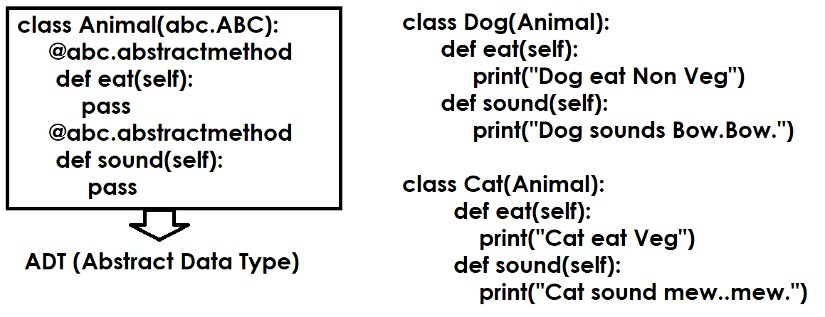
In application development abstract method is used when more than one method provides similar role with different implementation.
Abstract method must override by implemented class or inherited class.

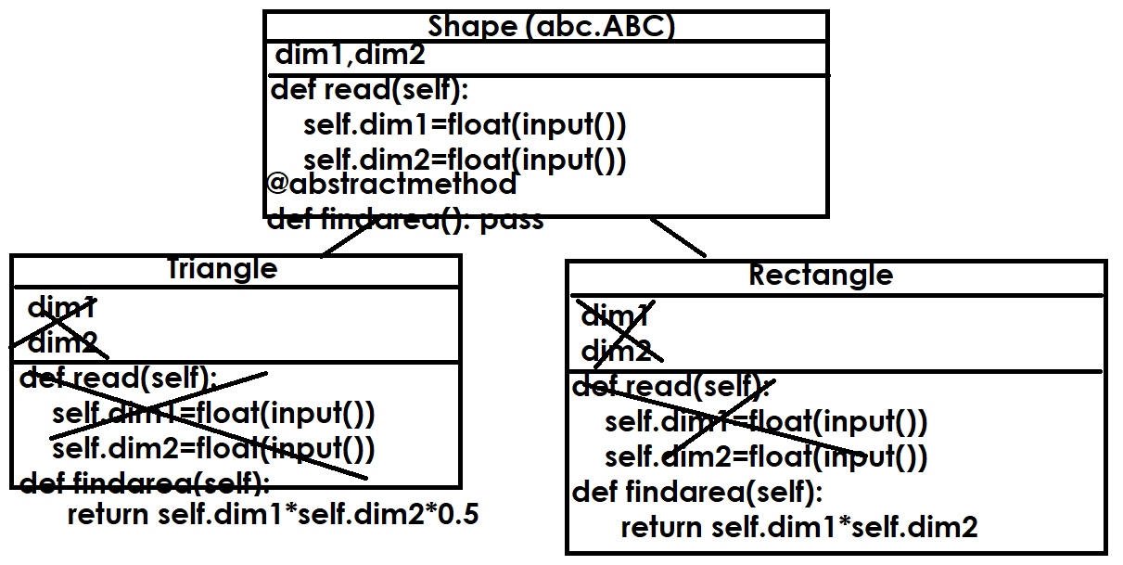
Example:
import abc
class Shape(abc.ABC):
def __init__(self):
self._dim1=None
self._dim2=None
def readDim(self):
self._dim1=float(input("Dim1 :"))
self._dim2=float(input("Dim2 :"))
@abc.abstractmethod
def findArea(self):
pass

class Triangle(Shape):
def findArea(self): # Overiding Method
return self._dim1*self._dim2*0.5

class Rectangle(Shape):
def findArea(self): # Overriding Method
return self._dim1*self._dim2

#s1=Shape()
t1=Triangle()
r1=Rectangle()
t1.readDim()
area1=t1.findArea()
r1.readDim()
area2=r1.findArea()
print(f'Area of Triangle is {area1}')
print(f'Area of Rectangle is {area2}')

Output
Dim1 :1.2
Dim2 :1.5
Dim1 :1.5
Dim2 :1.8
Area of Triangle is 0.8999999999999999
Area of Rectangle is 2.7

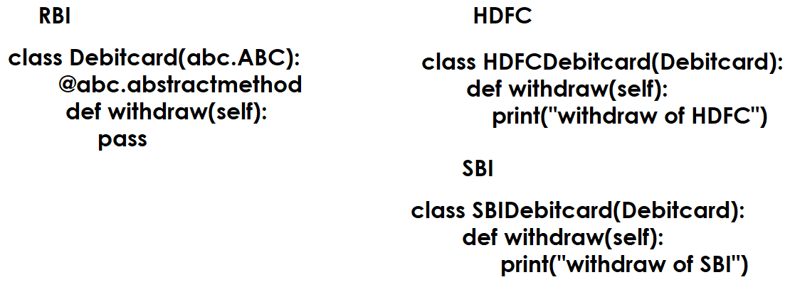
An abstract class which consists of only abstract methods is called interface (OR) interface is pure abstract class.

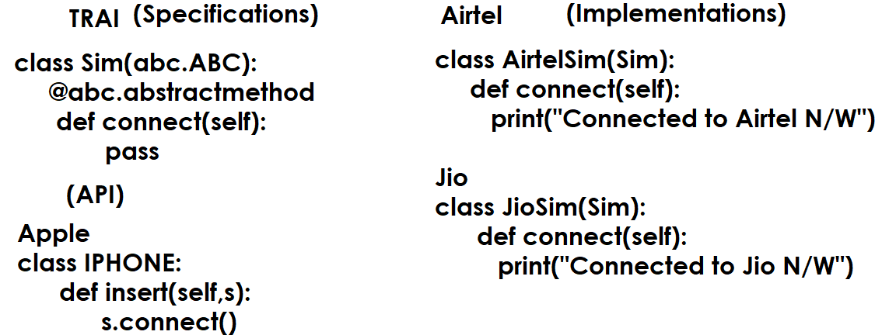

Example:
import abc
class Sim(abc.ABC):
@abc.abstractmethod
def connect(self):
pass

class AirtelSim(Sim):
def connect(self):
print("Connects to Airtel N/W")

class JioSim(Sim):
def connect(self):
print("Connects to Jio N/W")

class IPhone:
def insert(self,s):
s.connect()

sim1=AirtelSim()
sim2=JioSim()
mobile1=IPhone()
mobile1.insert(sim1)
mobile1.insert(sim2)

Output
Connects to Airtel N/W
Connects to Jio N/W

Example
import abc
class Debitcard(abc.ABC):
@abc.abstractmethod
def withdraw(self):
pass

class HDFCDebitcard(Debitcard):
def withdraw(self):
print("withdraw from HDFC")

class SBIDebitcard(Debitcard):
def withdraw(self):
print("withdraw from SBI")

class ICICIATM:
def swap(self,d):
d.withdraw()

atm1=ICICIATM()
card1=HDFCDebitcard()
card2=SBIDebitcard()
atm1.swap(card1)
atm1.swap(card2)

using abstract classes and abstract methods we can achieve abstraction.

What is abstraction?
Abstraction is process of hiding implementation details from caller by giving only specifications.
Caller calls the implementations without knowing specifications.

- A person who develop abstracts
- A person who implements abstract
- A person who calls the implementations using abstracts

Python is dynamically typed programming language, the type of variable changes based on object assigned.
Because python is dynamically typed programming language, using this we can achieve runtime polymorphism.
In runtime polymorphism the behavior of reference variable changes based on the type of object assigned.

Object Oriented Programming
- Encapsulation
- Polymorphism
- Inheritance
- Class
- Object
- Abstraction

Exception Handling (OR) Error Handling

In application development we come across 3 types of errors.

Types of Errors
- Compile time Errors
- Logical Errors
- Runtime Errors

Compile time Errors
The errors which occur during compilation of program are called compile time errors. All syntax errors are called compile time errors.
If there is syntax error within program, program is not executed.

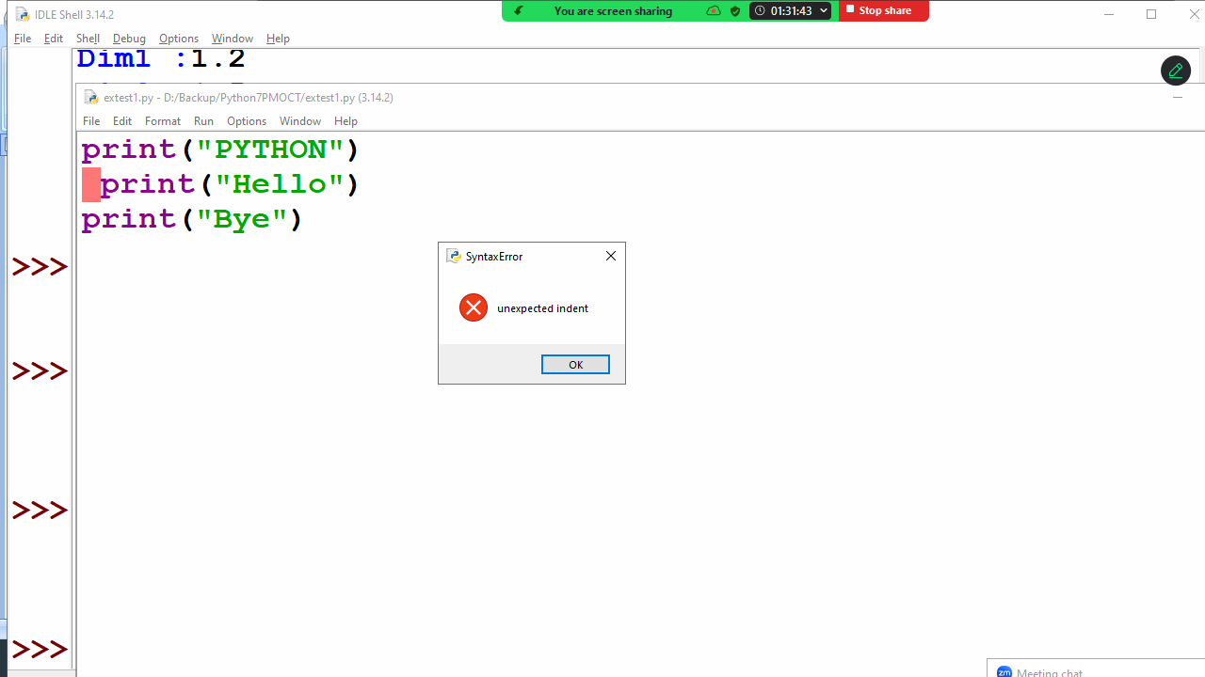
Syntax errors are rectified by programmer in order to execute program.

Logical Errors
A logical error is a programming logic error.
If there is logical error, program is executed but gives wrong result.

#Program to print sum of 2 numbers
n1=10
n2=5
n3=n1-n2 # Logical Error
print(n1,n2,n3)

Output
10 5 5

# finding max of two numbers
n1=10
n2=5
if n1>n2: # Logical Error
print(n2)
else:
print(n1)

Output
5

Logical errors are rectified by programmer in order to give accurate result.

